Rose Pekarek & Kyle Kleinschmidt

Option 3: Regional Tourism Guide
- Fallout New Vegas theme/location. Post apocalyptic and retro-futuristic aesthetic.
- Pages:
  - (Home) New Vegas Tour
    - Pip boy inspired- green text on black backgrounds. Metal accents if applicable. Year 2296
  - (Page 1) Dinky The Dino (Rose)
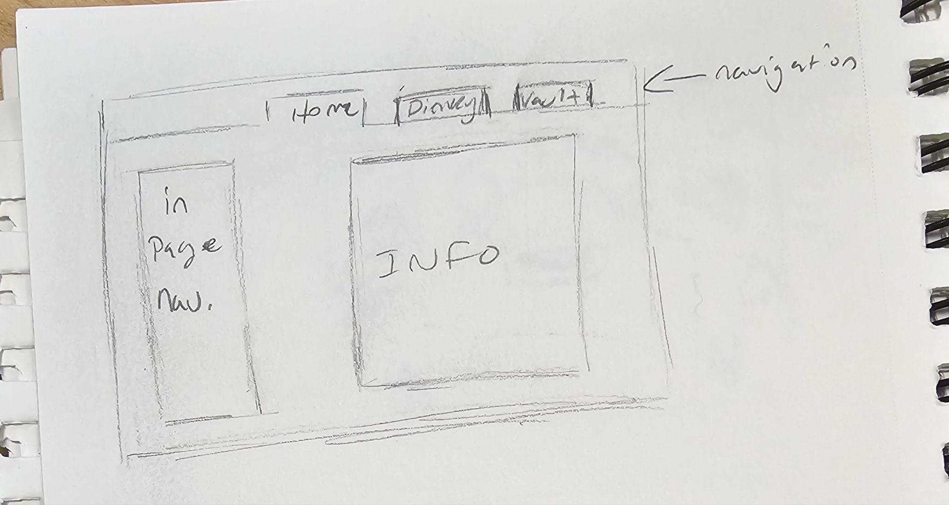
  - (Page 2) Vault 21(Kyle)
  - https://www.w3schools.com/jsref/tryit.asp?filename=tryjsref_onclick_dropdown

Group Members: __Kyle___, ___Rose____,
Project Theme: __Regional Tourism Guide____
Real or Fictional: ___Fictional (Fallout)____

Communication
Primary communication method: ☐ Text ☐ Discord ☐ Slack ☐ Other: ______
Group chat/channel name: ____NA______
Expected response time: ___ASAP except on weekends_______

File Management
Shared folder location: ____GitHub Repository_______
File naming convention: ___camelCase__

Work Division
Person | Page Assigned | Files They Own
Person A: _Kyle__ | __Vault 21 Hotel (content page 1)__ | __vault.html_______
Person B: _Rose____ | __Dinky the Dino (content page 2)_____ | __dino.html______
Everyone: | Home Page | index.html, shared CSS

Working Rules
☐ Only work on YOUR assigned files (unless agreed otherwise)
☐ Post in group chat when you finish a major task
☐ Ask for help when stuck (don't struggle alone!)
☐ Test your work before sharing
☐ Save and backup frequently
☐ Be kind and supportive to teammates

Check-in Schedule
Between 11-2 and 12-1: ______as needed in the morning_________
Between 12-1 and 12-2: ___as needed in the morning_____

